# *OPERATING SYSTEM LAB ASSIGNMENT – IV*

# 4ITRC2

Shreyansh Gupta

BE II Year

Information Technology ‘A’

# **Aim:**

To create shell scripts for the following questions

# **To perform:**

To code and solve the following

1. **To find Largest of Three Numbers**

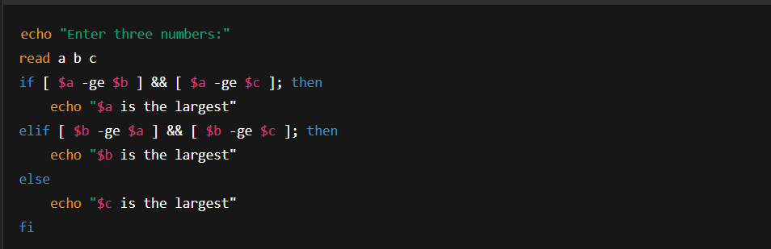

**2. To find a year is leap year or not.**

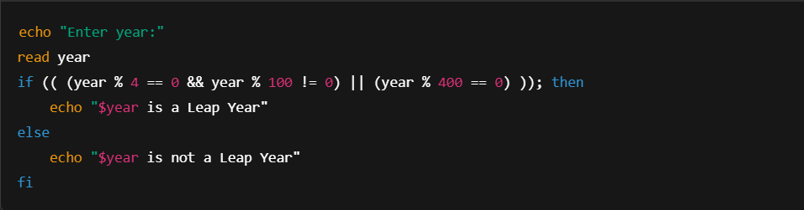

**3.** **To input angles of a triangle and find out whether it is valid triangle or not**

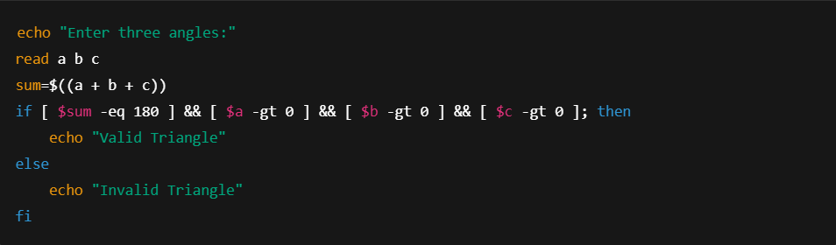

**4.** **To check whether a character is alphabet, digit or special character.**

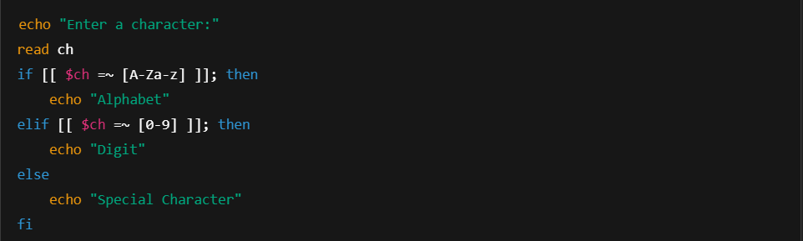

**5.** **To calculate profit or loss**

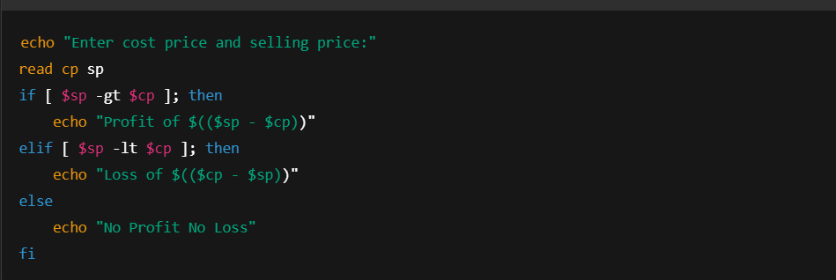

**6.** **To print all even and odd number from 1 to 10**

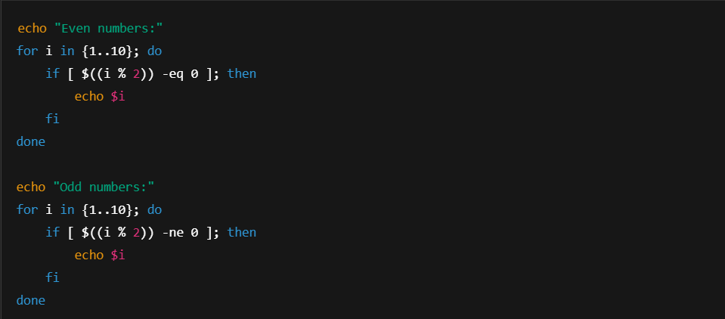

**7. To print table of a given number**

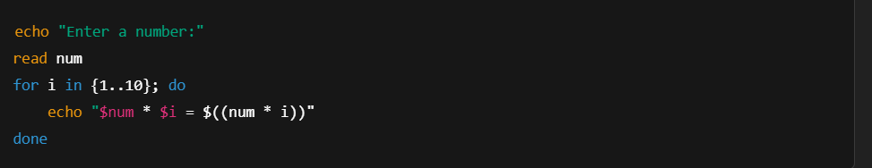

**8.** **To find factorial of a given integer**

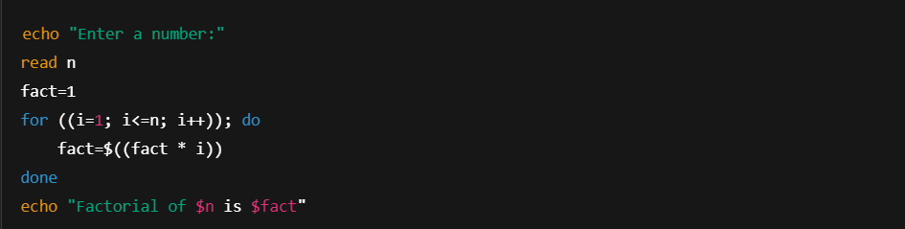

**9.** **To print sum of all even numbers from 1 to 10**

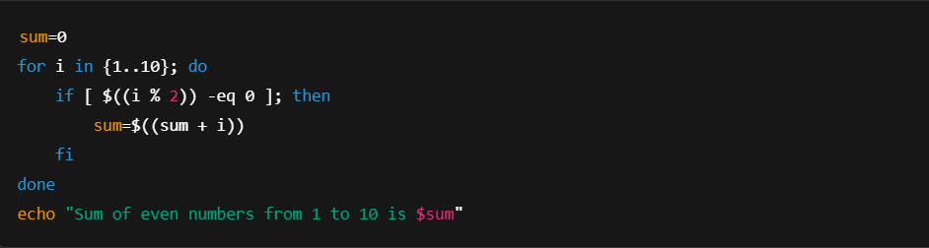

**10.** **To print sum of digit of any number.**

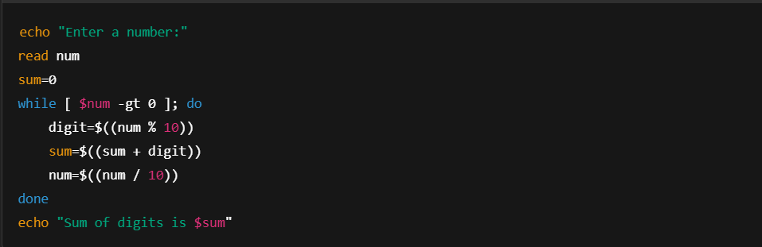

**11.** **To make a basic calculator which performs addition, subtraction, Multiplication, division**

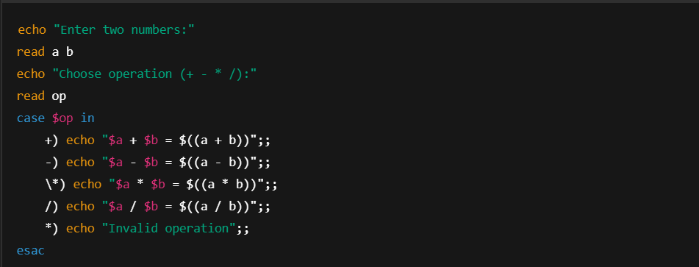

**12.** **. To print days of a week.**

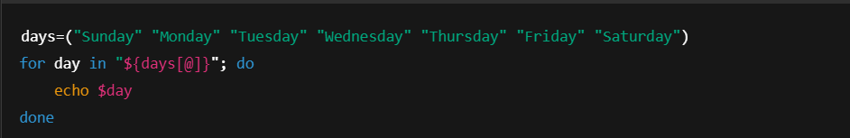

**13.** **To print starting 4 months having 31 days.**

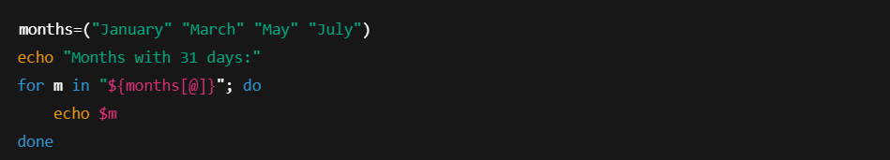

**14.** **Using functions**

a. To find given number is Amstrong number or not

b. To find whether a number is palindrome or not

c. To print Fibonacci series upto n terms

d. To find given number is prime or composite

e. To convert a given decimal number to binary equivalent

a.

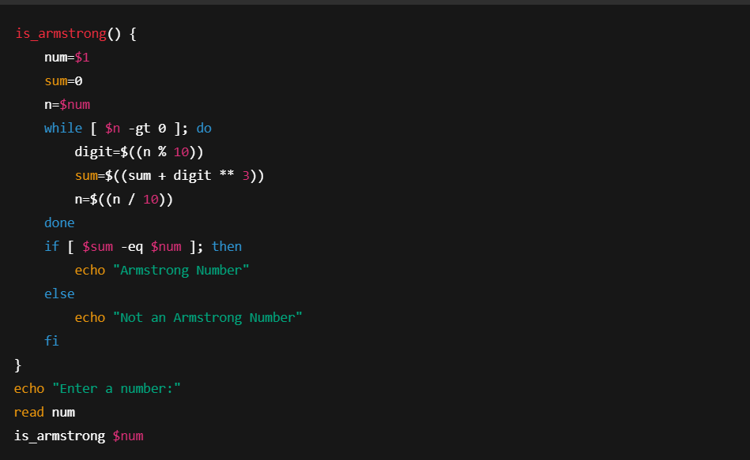

b.

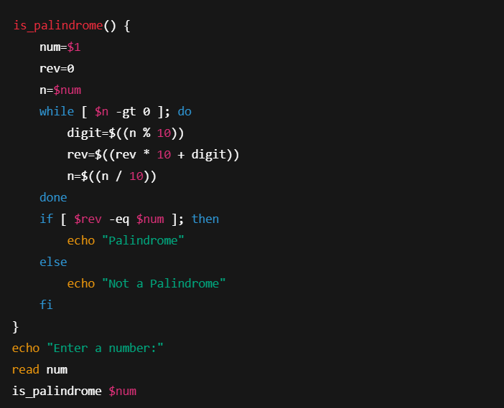

c.

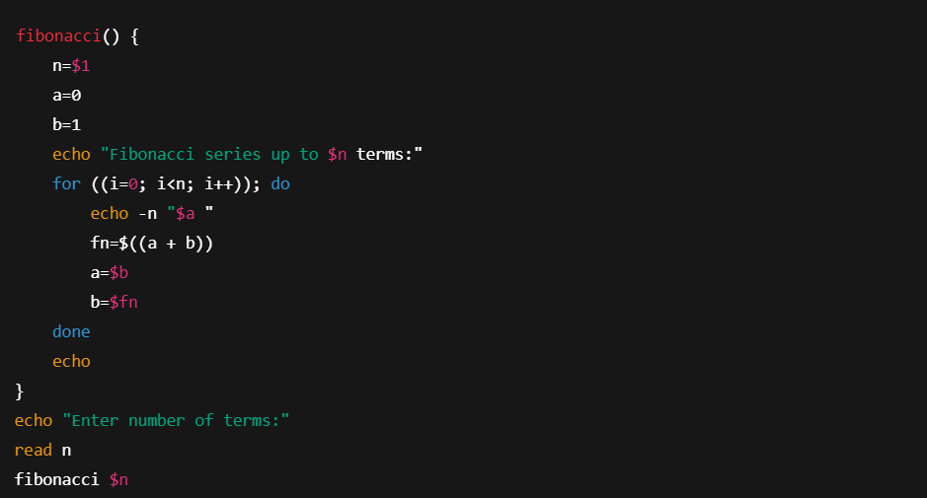

d.

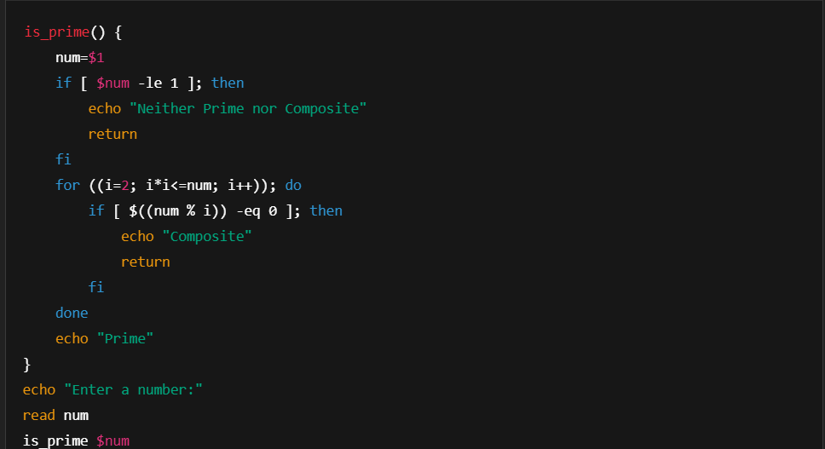

e.

